Mid-Atlantic States Lake Forum
Hosted by The Maryland Department of Natural Resources

Funding provided by :
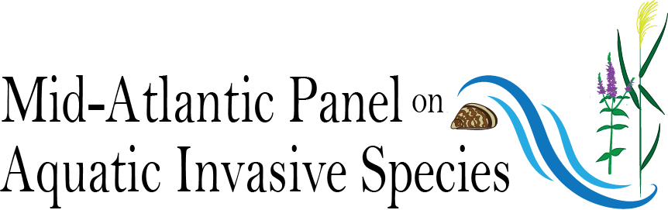

April 9th, 2019
Chesapeake Bay Foundation
6 Herndon Ave.
Annapolis, MD 21403
410-268-8816
www.cbf.org
https://zoom.us/j/230642297
+1 929 205 6099
Code: 230 642 297

AGENDA

8:30 am | Coffee and light breakfast
9:00 am | Call to order Welcome/housekeeping |  | Mark Lewandowski, Lake Forum Chair
9:20 am | Keynote speaker-North American Lake Management Society(NALMS)- Region 3 state of the union |  | Lisa Borre, NALMS Region 3 Director
9:45 am | Overview of AIS issues in MD |  | Mike Naylor, Maryland Department of Natural Resources
10:05 am  10:25 am | Lake Champlain/Lake George AIS inspection programs- keeping invaders out.  Break |  | Dr. Eric Holmlund, Adirondack Watershed Institute Stewardship Program
10:40 am  11:00 am | Fisheries management.-Delaware lakes and ponds  Pymatuning State Park hydrilla management |  | Mike Steiger, DE Division of Fish and Wildlife  Nick Decker, PA Department of Conservation and Natural Resources
11:20 am | PALMS- Current events in the Pennsylvania Lake Management Society |  | Nick Decker, PA Department of Conservation and Natural Resources
11:40 am | Volunteer lake monitoring – Engaging our citizenry to keep our lakes clean |  | Beth Norman Lacawac Sanctuary
12:00 pm | Lunch
1:00 pm  1:20 pm  1:40 pm | Voluntary boat inspections-Deep Creek Lake Launch Steward program  Assessing the risk of future aquatic invasive species establishment in a changing world  CD3-Portable cleaning units- How can it benefit our lakes |  | Seth Metheny, Maryland Park Service  Sara Stahlman, PA Sea Grant  Edgar Rudberg, CD3 Stations
2:00 pm  2:20 pm | Herbicide management as part of integrated strategies for control of invasive and nuisance aquatic plants  Harmful algal blooms- Understanding the need for management |  | Dr. Rob Richardson, North Carolina State University  Dr. West Bishop, SePRO
2:40 pm  3:00 pm | Break  Zebra mussel protection |  | Clark Howells, Baltimore City Reservoirs
3:20 pm  3:40 pm  4:00 pm | Quagga mussel eradication  Managing multi-purpose lakes and ponds in Columbia, MD  Sustainable pond and lake management practices |  | Ellyn Campbell, Susquehanna River Basin Commission  John McCoy, Columbia Association  Wes Allen, Solitude
4:20 pm | USGS NAS database- Tracking AIS movements |  | Ian Pfingsten, U.S. Geological Survey
4:45 pm | Wrap-up and adjourn for the day

